
המחלקה להנדסת חשמל ואלקטרוניקה

מערכות לומדות ולמידה עמוקה (31245)

Lab 1 report

פרנסיס עבוד

Prepared for: Dr. Amer Adler

Date: 26/03/2025
Ex.4:
Write a Python program that calculates the area of a circle based on the radius entered by the user.
Solution:
Code:
import math
Pi=math.pi;
R=float(input("enter the Radius:"))
A=Pi*R**2
print("the Area of the circle is:",A)

Output:
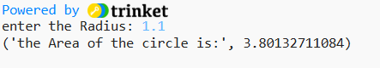
Ex.5:
Write a Python program that accepts the user's first and last name and prints them in reverse order with a space between them.
Solution:
Code:
my_first_name=input("enter your first name")
my_last_name=input("enter your last name")
print(my_last_name + " " + my_first_name)

Output:
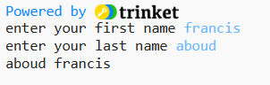
Ex.6:
Write a Python program that accepts a sequence of comma-separated numbers from the user and generates a list and a tuple of those numbers.
Solution:
Code:
value=input("Input numbers separated by comma")
list=value.split(",")
tuple = tuple(list)
print("list-> ",list)
print("tuple-> ",tuple)

Output:
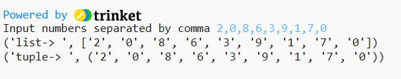
Ex.7:
Write a Python program that accepts a filename from the user and prints the extension of the file.
Solution:
Code:
File=input("Input filename")
F=File.split(".")
print("the File extension is:", F[-1])

Output:
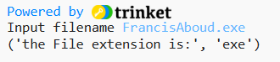
Ex.8:
Write a Python program to display the first and last colors from the following list.
Solution:
Code:
color_list = ["Red","Green","White" ,"Black"]
print(color_list[0],color_list[-1])

Output:
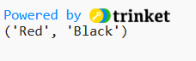

Ex.9:
Write a Python program to display the examination schedule. (extract the date from exam_st_date).
Solution:
Code:
exam_date = (11, 12, 2014)
print("%i / %i / %i"%exam_date)

Output:
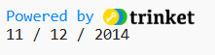

Ex.10:
Write a Python program that accepts an integer (n) and computes the value of n+nn+nnn.
Solution:
Code:
n=int(input("Input an integer"))
b=int(n*10+n)
c=int(n*100+n*10+n)
print("the sum of n+nn+nnn=",n+b+c)

Output:
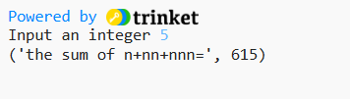

Ex.11:
Write a Python program to print the documents (syntax, description etc.) of Python built-in function(s).
Solution:
Code:
func_name = input("Enter the built-in function name: ")
func = eval(func_name)
print(func.__doc__)

Output:
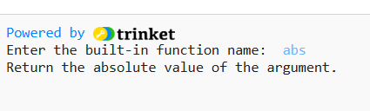
Ex.12:
Write a Python program that prints the calendar for a given month and year.
Solution:
Code:
import calendar
year=int(input("Input the Year:"))
month=int(input("Input the Month:"))
print(calendar.month(year,month))

Output:
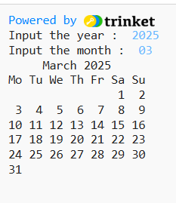
Ex.13:
Write a Python program to print the following 'here document'.
Solution:
Code:
print("""
a string that you "don't" have to escape
This
is a ....... multi-line
heredoc string --------> Francis
""")
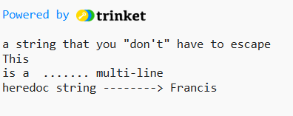
Output:

Ex.14:
Write a Python program to calculate the number of days between two dates.
Solution:
Code:
from datetime import date

def input_date(prompt):
print(prompt)
year = int(input("Year: "))
month = int(input("Month: "))
day = int(input("Day: "))
return date(year, month, day)

date1 = input_date("Enter the first date:")
date2 = input_date("Enter the second date:")

difference = abs((date2 - date1).days)

print(f"Number of days between the two dates: {difference} days")

Output:
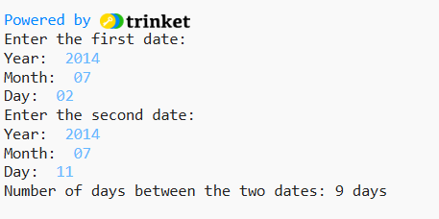

Ex.15:
Write a Python program to get the volume of a sphere with radius six.
Solution:
Code:
from math import pi
R=6
volume=4/3*pi*R**3
print("the volume of a sphere with radius six is: ", volume)

Output:
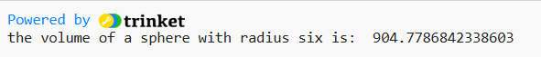

Ex.16:
Write a Python program to calculate the difference between a given number and 17. If the number is greater than 17, return twice the absolute difference.
Solution:
Code:
def diff(n):
if n>17:
return (n-17)*2
else:
return 17-n

n=int(input("enter a number"))
print(diff(n))

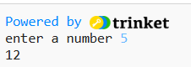
Output:

Ex.17:
Write a Python program to test whether a number is within 100 of 1000 or 2000.
Solution:
Code:
def near(n):
if abs(1000-n)<=100 or abs(2000-n)<=100:
print("True")
else:
print("False")

n=int(input("enter a number: "))
print(near(n))

Output:
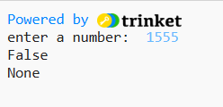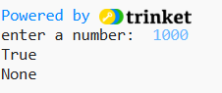

Ex.18:
Write a Python program to calculate the sum of three given numbers. If the values are equal, return three times their sum.
Solution:
Code:
def sum(a,b,c):
if a==b==c:
return a*3
else:
return a+b+c

n1=int(input("enter a numbr: "))
n2=int(input("enter a numbr: "))
n3=int(input("enter a numbr: "))
print(f"the First number: {n1} \n the second number: {n2} \n the third number: {n3}")
print(sum(n1,n2,n3))

Output:
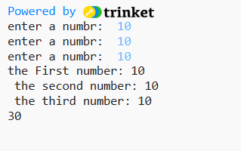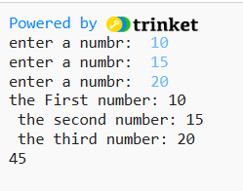

Ex.19:
Write a Python program to get a newly-generated string from a given string where "Is" has been added to the front. Return the string unchanged if the given string already begins with "Is".
Solution:
Code:
def new(text):
if len(text) >= 2 and text[:2] == "Is":
return text
else:
return "Is" + text
print(new("My"))
print(new("Name"))
print(new("IsFrancis"))

Output:
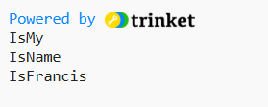

Ex.20:
Write a Python program that returns a string that is n (non-negative integer) copies of a given string.
Solution:
Code:
def repeate(string,n):
text=" "
for i in range(n):
text = text+string
return text

print(repeate('DeepLearning ' ,4))
print(repeate('<_>' ,5))

Output:
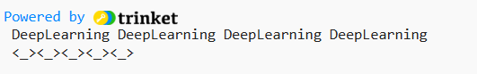

Ex.21:
Write a Python program that determines whether a given number (accepted from the user) is even or odd, and prints an appropriate message to the user.
Solution:
Code:
def evenorodd(n):
mod=n%2
if mod==0:
print(f"the number {n} is even")
else:
print(f"the number {n} is odd")

n=int(input("enter a number"))
print(evenorodd(n))

Output:
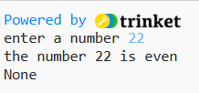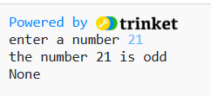

Ex.22:
Write a Python program to count the number 4 in a given list.
Solution:
Code:
def count_4(numbers):
counter = 0
for n in numbers:
if n == 4:
counter += 1
return counter

list_m = [6, 2, 4, 2, 5, 4, 4, 4]
print(list_m)
print(f"the number 4 has appeared: {count_4(list_m)}")

Output:
